1. What is Statistics
2. Data types in statistics

* Numerical
* Discrete
* Conti
* Categorical

1. Levels of data

* Nominal level
* Ordinal level
* Interval level : No zero scale
* Ratio level : Has Zero scale

1. Population
2. Sample
3. Population vs sample
4. Inferential statistics
5. Frequency table
6. Relative frequency table
7. Bar chart
8. Pie chart
9. Frequency distribution table
10. Histogram
11. Distribution plot
12. Central tendency

* Mean
* Median
* Mode

1. Mean vs Median
2. Outlier
3. Distribution Uni mode bi mode
4. Types of Distribution
5. Negative skewed : Left Skewed : Mean < Median<Mode
6. Positive skewed : Right Skewed: Mean > Median > Mode
7. No skew : Bell shaped : Normal distribution : Mean= Median =mode
8. Asymptotes : will never touch the real axis

In order to understand the distribution

Central tendency : Middle point analysis

Data flow or Data distribution

1. Range
2. Mean deviation
3. Absolute mean deviation
4. Variance
5. Standard deviation
6. Range

1 to 100

Min Max

Range= Max-Min= 100-1= 99

Data divide into 99 parts

Disadvantage :

This method concentrates only on end values rather than middle values

1. Mean deviation:

How much each observation or data point or sample or tuple is deviated from mean value

In a data we have rows : Observations, Data points , sample , tuple

Columns: Variables , features, Dimensions, Predictors

Assume that we have 5 observations are there

$$x_{1}=1,x_{2}=2,x_{3}=3,x_{4}=4,x_{5}=5$$

$$mean=\overline{x}=\frac{x_{1}+x_{2}+x_{3}+x_{4}+x_{5}}{N}$$

$$mean=\overline{x}=\frac{1+2+3+4+5}{5}=3$$

$$Deviation of First observation from mean={(x}_{1}-\overline{x})=1-3=-2$$

$$Deviation of second observation from mean={(x}_{2}-\overline{x})=2-3=-1$$

$$Deviation of Third observation from mean={(x}_{3}-\overline{x})=3-3=0$$

$$Deviation of Fourth observation from mean={(x}_{4}-\overline{x})=4-3=1$$

$$Deviation of Fifth observation from mean={(x}_{5}-\overline{x})=5-3=2$$

$$Total deviation= -2-1+0+1+2=0(Draw back)$$

$$Total deviation=\frac{1}{5}* [{(x}_{1}-\overline{x})+{(x}_{2}-\overline{x})+{(x}_{3}-\overline{x})+{(x}_{4}-\overline{x})+{(x}_{5}-\overline{x})]$$

$$Total deviation=\frac{1}{5}*\sum_{i=1}^{5}{{(x}_{i}-\overline{x})}$$

$$Total deviation=\frac{1}{N}*\sum_{i=1}^{N}{{(x}_{i}-\overline{x})}$$

Anand kumar says : Mod

1. Absolute mean deviation:

Assume that we have 5 observations are there

$$x_{1}=1,x_{2}=2,x_{3}=3,x_{4}=4,x_{5}=5$$

$$mean=\overline{x}=\frac{x_{1}+x_{2}+x_{3}+x_{4}+x_{5}}{N}$$

$$mean=\overline{x}=\frac{1+2+3+4+5}{5}=3$$

$$Absolute Deviation of First observation from mean={|x}_{1}-\overline{x}|=\left|1-3\right|=\left|-2\right|=2$$

$$Absolute Deviation of second observation from mean={|x}_{2}-\overline{x}|=\left|2-3\right|=\left|-1\right|=1$$

$$Absolute Deviation of Third observation from mean={|x}_{3}-\overline{x}|=|3-3|=0$$

$$Absolute Deviation of Fourth observation from mean={|x}_{4}-\overline{x}|=|4-3|=1$$

$$Absolute Deviation of Fifth observation from mean={|x}_{5}-\overline{x}|=|5-3|=2$$

$$Total deviation= 2+1+0+1+2=6$$

$$Total deviation=\frac{1}{5}* [{|x}_{1}-\overline{x}|+{|x}_{2}-\overline{x}|+{|x}_{3}-\overline{x}|+{|x}_{4}-\overline{x}|+{|x}_{5}-\overline{x}|]$$

$$Total deviation=\frac{1}{5}*\sum_{i=1}^{5}{{|x}_{i}-\overline{x}|}$$

$$Absolute mean deviation(AMD)=\frac{1}{N}*\sum_{i=1}^{N}{{|x}_{i}-\overline{x}|}$$

$$Mean deviation(MD)=\frac{1}{N}*\sum_{i=1}^{N}{{(x}_{i}-\overline{x})}$$

$$What is the draw back of AMD:$$

|  |  |  |
| --- | --- | --- |
| X | Y=x | Y=|x| |
| -2 | -2 (-2,-2) | 2 (-2,2) |
| -1 | -1 (-1,-1) | 1 (-1,1) |
| 0 | 0 (0,0) | 0 (0,0) |
| 1 | 1 (1,1) | 1 (1,1) |
| 2 | 2 (2,2) | 2 (2,2) |

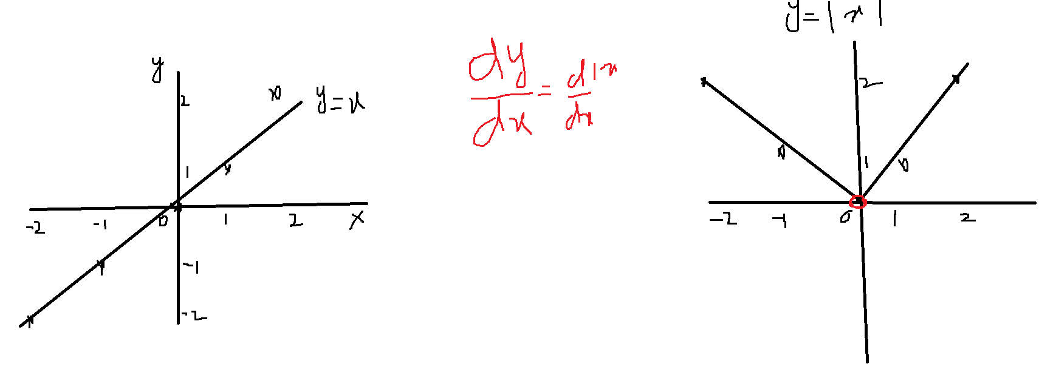

Draw back:

Absolute mean deviation related to absolute value

4. Variance:

Assume that we have 5 observations are there

$$x_{1}=1,x_{2}=2,x_{3}=3,x_{4}=4,x_{5}=5$$

$$mean=\overline{x}=\frac{x_{1}+x_{2}+x_{3}+x_{4}+x_{5}}{N}$$

$$mean=\overline{x}=\frac{1+2+3+4+5}{5}=3$$

$$variance of First observation from mean={(x_{1}-\overline{x})}^{2}={\left(1-3\right)}^{2}=4$$

$$Variance of second observation from mean={(x_{2}-\overline{x})}^{2}={\left(2-3\right)}^{2}=1$$

$$Variance of Third observation from mean={(x_{3}-\overline{x})}^{2}={\left(3-3\right)}^{2}=0$$

$$Variance of Fourth observation from mean={(x_{4}-\overline{x})}^{2}={\left(4-3\right)}^{2}=1$$

$$Variance of Fifth observation from mean={(x_{5}-\overline{x})}^{2}={\left(5-3\right)}^{2}=4$$

$$Total deviation= 4+1+0+4+1=10$$

$$Variance=\frac{1}{5}* [{(x_{1}-\overline{x})}^{2}+{(x_{2}-\overline{x})}^{2}+{(x_{3}-\overline{x})}^{2}+{(x_{4}-\overline{x})}^{2}+{(x_{5}-\overline{x})}^{2}]$$

$$Variance=\frac{1}{5}*\sum_{i=1}^{5}{{(x_{i}-\overline{x})}^{2}}$$

$$Variance=\frac{1}{N}*\sum_{i=1}^{N}{{(x_{i}-\overline{x})}^{2}}$$

$$Mean deviation=\frac{1}{N}*\sum_{i=1}^{N}{{(x}_{i}-\overline{x}) (Total deviation=0)}$$

$$Absolute mean deviation(AMD)=\frac{1}{N}*\sum_{i=1}^{N}{{|x}_{i}-\overline{x}| (Not differentiable)}$$

$$Variance=\frac{1}{N}*\sum_{i=1}^{N}{{(x_{i}-\overline{x})}^{2}}$$

1. Error is increasing
2. Units also raise

Km Fare

2 10

3 11

(2km-2.5km)^2 = 0.5km^2 km^2

5. Standard Deviation

$$standard deviation (σ)=\sqrt{variance}$$

$$standard deviation (σ)=\sqrt{\frac{1}{N}*\sum_{i=1}^{N}{{(x_{i}-\overline{x})}^{2}}}$$

$$Mean deviation=\frac{1}{N}*\sum_{i=1}^{N}{{(x}_{i}-\overline{x}) (Total deviation=0)}$$

$$Absolute mean deviation(AMD)=\frac{1}{N}*\sum_{i=1}^{N}{{|x}_{i}-\overline{x}| (Not differentiable)}$$

$$Variance=\frac{1}{N}*\sum_{i=1}^{N}{{(x_{i}-\overline{x})}^{2}}$$

$$standard deviation (σ)=\sqrt{\frac{1}{N}*\sum_{i=1}^{N}{{(x_{i}-\overline{x})}^{2}}}$$

|  |  |  |  |
| --- | --- | --- | --- |
| X | Y=x | Y=|x| | Y=x^2 |
| -2 | -2 (-2,-2) | 2 (-2,2) | 4 |
| -1 | -1 (-1,-1) | 1 (-1,1) | 1 |
| 0 | 0 (0,0) | 0 (0,0) | 0 |
| 1 | 1 (1,1) | 1 (1,1) | 1 |
| 2 | 2 (2,2) | 2 (2,2) | 4 |

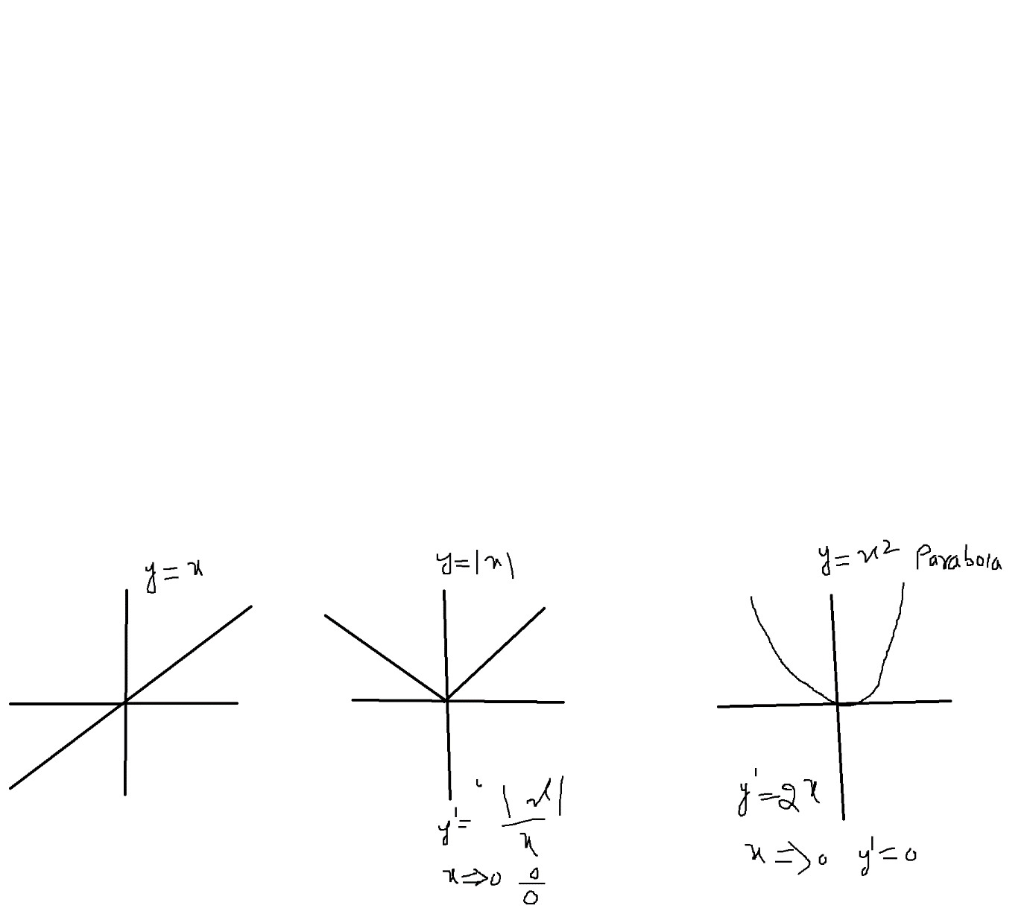

Y=mx+c

Y= |x|

Y=x^2

Y=logx loge log10 log2

Normal scale vs Log scale

Y= sinx cosx tanx

Covariance:

Co : two

How a variable is varying w.r.t to another variable

Age Salary

30 50k

31 55k

32 70k

Var(Salary)

50 55 70 mean= (50+55+70)/3= 175/3= 58

|  |  |  |
| --- | --- | --- |
| Salary | (xi-xbar)^2 | $$\frac{1}{N}*\sum_{i=1}^{N}{{(x_{i}-\overline{x})}^{2}}$$ |
| 50 | (50-58)^2 | 64 |
| 55 | (55-58)^2 | 9 |
| 70 | (70-58)^2 | 144 |

Step-1: Calculate the mean : 58

Step-2: Xi-xbar : 50-58=-8

Step-3: square of that step-2 value : 64

Step-4: summation: 64+9+144= 217

Step-5: Divide by num observations= 217/3=72

Covariance:

$$Variance=\frac{1}{N}*\sum_{i=1}^{N}{{(x_{i}-\overline{x})}^{2}}$$

$$Variance\left(x\right)=Cov(x,x)=\frac{1}{N}*\sum_{i=1}^{N}{\left(x_{i}-\overline{x}\right)*(x_{i}-\overline{x})}$$

$$Cov(x,y)=\frac{1}{N}*\sum_{i=1}^{N}{\left(x_{i}-\overline{x}\right)*(y_{i}-\overline{y})}$$

Covariance Matrix:

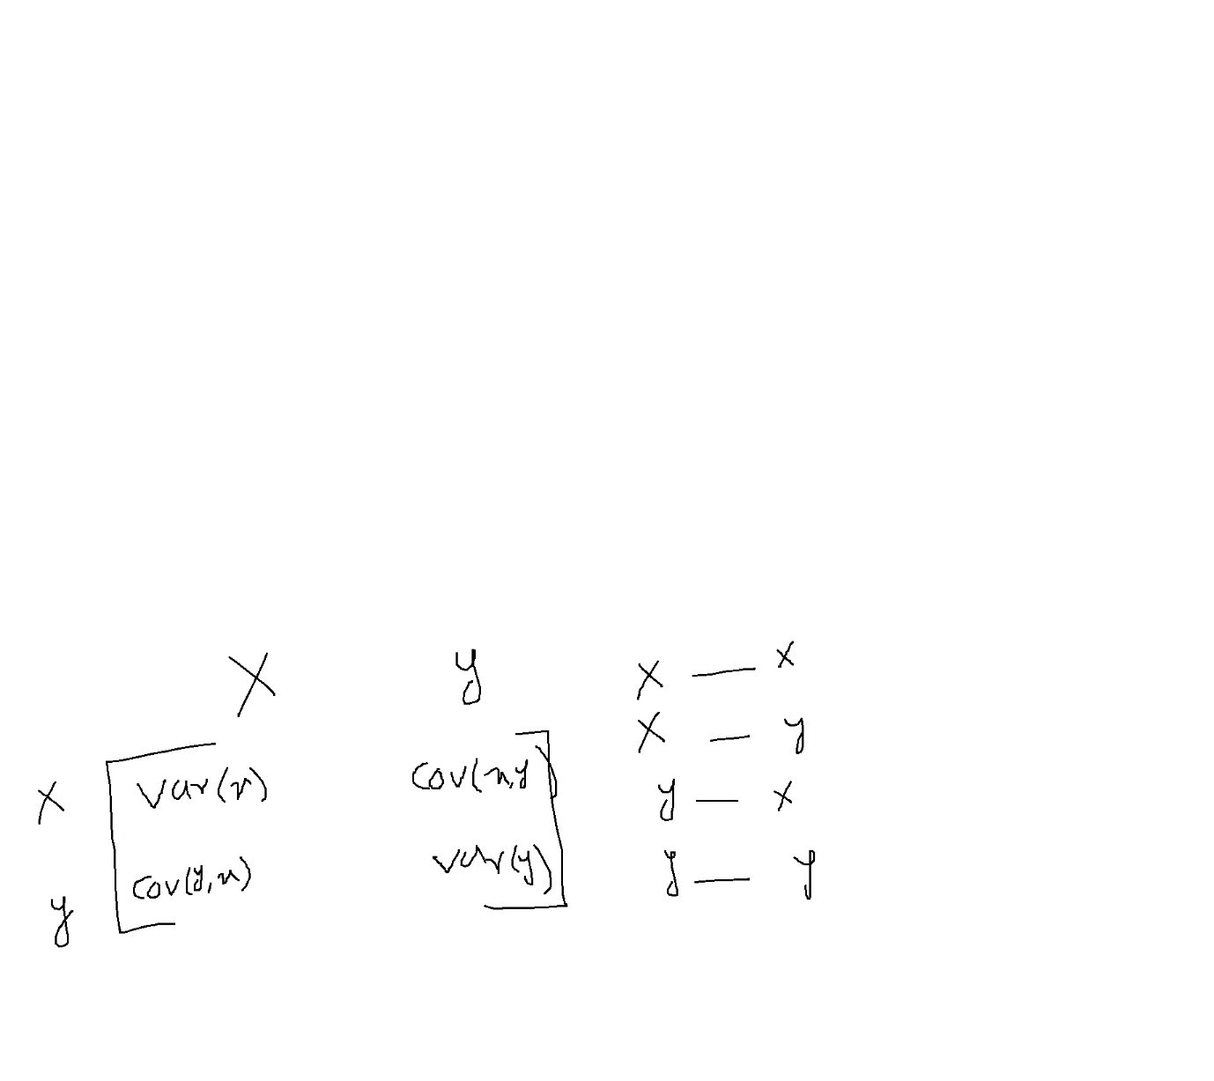

$$Variance\left(x\right)=Cov\left(x,x\right)$$

$$Variance\left(y\right)=Cov(y,y)$$

$$Cov\left(x,y\right)=Cov\left(y,x\right)$$

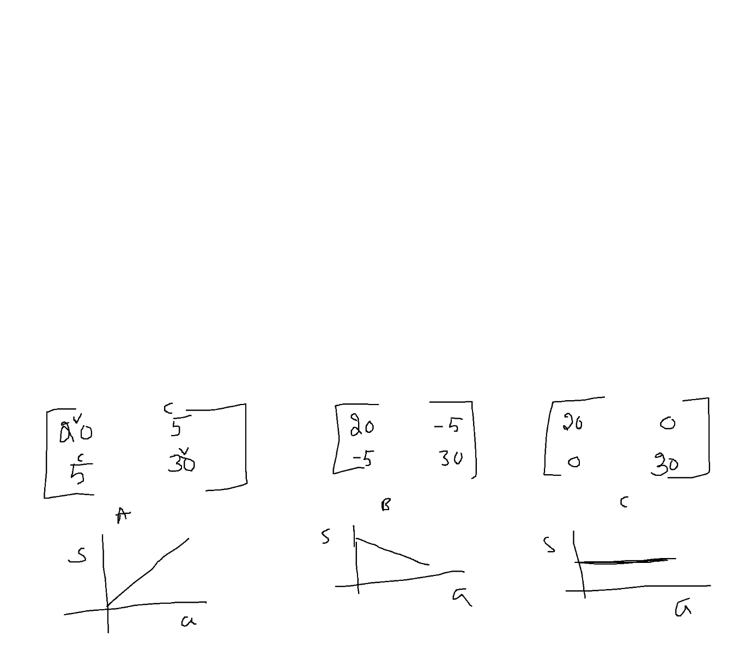

Covariance gives relation between two variables

Positively related : $$Cov\left(x,y\right)=Cov\left(y,x\right)=+ve$$

Negatively related

$$Cov\left(x,y\right)=Cov\left(y,x\right)=-ve$$

No relation

$$Cov\left(x,y\right)=Cov\left(y,x\right)=0 both are independen$$